**Oozie L0 practical task**

     Copy and run simple Oozie workflow

-        Oozie action: hive script

**PREPARATION**

Create directory for oozie jobs on HDFS

* /user/oozie_tasks/L0/

Copy files from “Shared server” (oozie/practical_task/L0) to newly created directory on HDFS

**EXECUTION**

- Go to Hue

- “File Browser”, than try to find /user/oozie_tasks/L0/

- Mark “workflow.xml” script

- Run “Submit” button

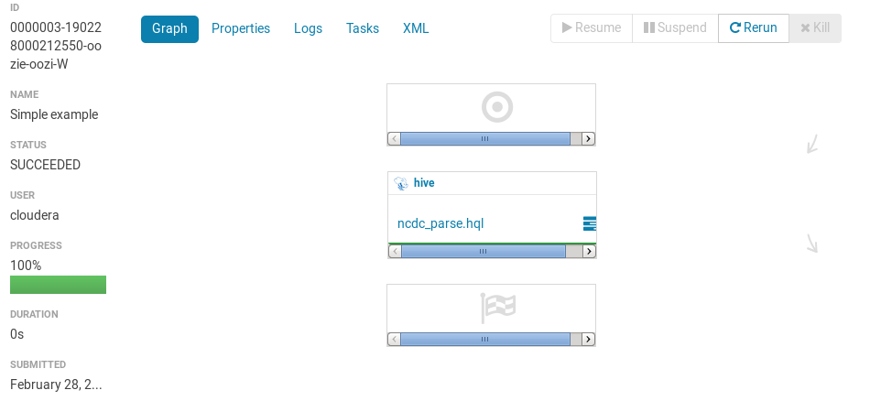

When the result of the actions will be green:

1. Create your own directory (name.surname) under /user/practical_task/L0/

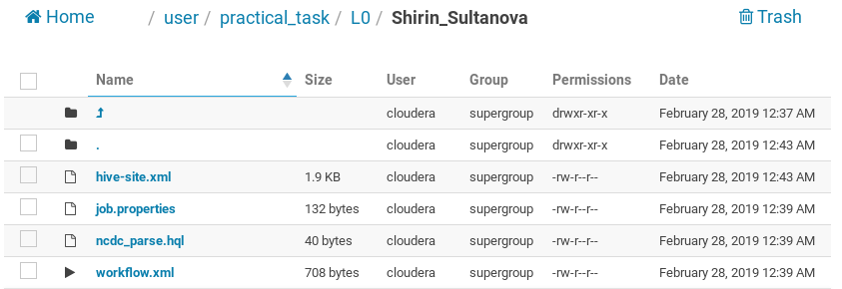

1. Copy there your Oozie files related to L0.
2. Copy a screenshot with Green Oozie workflow job.

